**Shady Haddad Project 1 Documentation**

**About: This document contains information about the entire project 1 and why I felt it was important for my last semester at Stockton University. I discuss how each assignment contributes to my learning and its importance. Before reading all the information I present I wanted to take a second to acknowledge how you take the time to care for your students and want them to learn so it can be applied in the work field. The class teaches how you need to be on top of your work and learn to be a little more independent. This class truly feels as if it can prepare you for a real work experience. To be honest no other class at Stockton University feels that way it's exactly how you put it. Our hands are being held so how are we supposed to learn? I’m glad this class teaches to have that independence because when it comes to real work there's not really any more hand-holding.**

**Table of Contents/OverView**

**Page 1-2.)**

* + **Overview of Project 1 Documentation**

**Page 3.) Assignment 1: Stats Library AND Assignment 2: GitHub Written Essay**

* + **Purpose (Personal Opinion)**
  + **Screenshot of Code**

**Page 4.) Assignment 3: Monte Carlo Three Doors AND Assignment 4: Birthday Problem**

* + **Purpose (Personal Opinion)**
  + **Screenshot of Code**

**Page 5.) Assignment 5: Pokemon Battler AND Assignment 6: Prizes “Rare Candy”**

* + **Purpose (Personal Opinion)**
  + **Screenshot of Code**

**Page 6.) Assignment 7: Pokemon In Opening Hand**

* + **Purpose (Personal Opinion)**
  + **Screenshot of Code**

**Page 7.) Assignment 8 : Formula sheet**

* + **Purpose (Personal Opinion)**

**Page 8.) Assignment 9 Pokemon TCG**

* + **Purpose (Personal Opinion)**
  + **Use of Inheritance/Screenshots**

**Page 9-13.) Pokemon TCG Manual AND Extra Credit Section**

* + **Manual for Shady’s Pokemon TCG Game**
  + **Extra credit discussion**

**Assignment 1 Stats Library Programmed In Java**

**Purpose (Personal Opinion):**

I believe the purpose of creating our stats library was to get familiarity with coding with math specifically in Java. Also, when you’re coding equations, you get familiar with them, making things easier to solve when doing a problem. Also creating formulas to check for each equation can help us check our homework answers which is an elegant tool. Overall I think the stats library was a helpful tool for us and anyone could benefit from creating one.

**Screenshot Of Code:**

Here is a screenshot of my code when I run it to test for each formula asked…

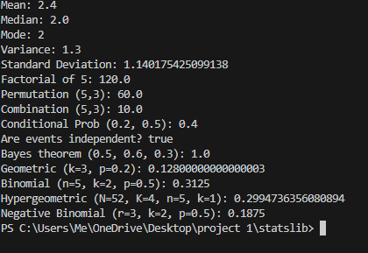

**Assignment 2 Github Written Essay**

**Purpose (Personal Opinion):**

Anyone who wants to become a professional developer should learn what Git is and how to use it. I believe the point of this assignment is to get familiar with Git in case you already were not. I knew how to use Git beforehand but still reading the information on that website is a great way for new people to learn. It refreshes your memory and gets you ready to start using the website.

**Screenshot Of Code:**

None needed.

**Assignment 3 Monte Carlo Three Doors**

**Purpose (Personal Opinion):**

In the first couple of lectures in class, we were introduced to a game show problem which is known as Monte Carlo. Professor, you asked us a game show question that was based on probability and asked someone to play and we eventually saw the reason because we wanted to see if probability affected your chances of winning by switching your door after opening one door the first time. The point of the code was to run that experiment numerous amount of times to see if those percentages would stay similar. After creating that code you can see switching your door after being asked gives you a higher probability of winning then keeping your door.

**Screenshot Of Code:**

As you can see in the results of the code swapping your door nearly doubles your chances of winning A BRAND NEW CAR!!! And NO GOAT!!!  
  
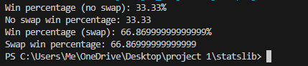

**Assignment 4 Birthday Problem**

**Purpose (Personal Opinion):**

In class one day we tried to figure out the probability that two people in the class would share a birthday. Then we were asked to make a program that would find the probability for us.

**Screenshot Of Code:**

**There is a 72 percent chance that 2 people in a class of 32 will share a birthday.**



**Assignment 5 Pokemon Battler**

**Purpose (Personal Opinion):**

This was a checkpoint for our main part of the project. This allowed us to have a piece to implement into our projects. Some people probably haven’t realized that throughout the semester you’ve given us pretty much all the pieces we needed for the project itself but we just had to put it all together. That was the bare minimum if you want a passing grade. Obviously, if you want to get a better grade you should implement more functions into the project.

**Screenshot Of Code:**

Here was a battle between Charmander and Pikachu which Charmander ultimately won.

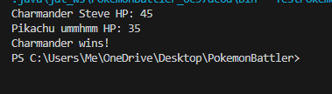

**Assignment 6 Prizes “Rare Candy”**

**Purpose (Personal Opinion):**

The purpose of this assignment is to draw cards from a deck to get an estimate of how often you brick by not getting any rare candys in your starting hand.

**Screenshot Of Code:**

Here are the probabilities for the chances of bricking depending on the rare candy count.

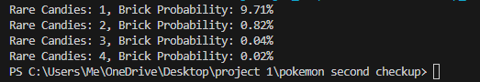

**Assignment 7 Pokemon In Opening Hand**

**Purpose (Personal Opinion):**

The purpose of this program is to help us understand the likelihood of drawing no Pokemon cards changes as the number of Pokemon cards in the deck gets bigger. We ran each simulation from 1 to 60 to show us how when you increase the amount of Pokemon Cards in the deck it reduces the chance of a mulligan.

**Screenshot Of Code:**

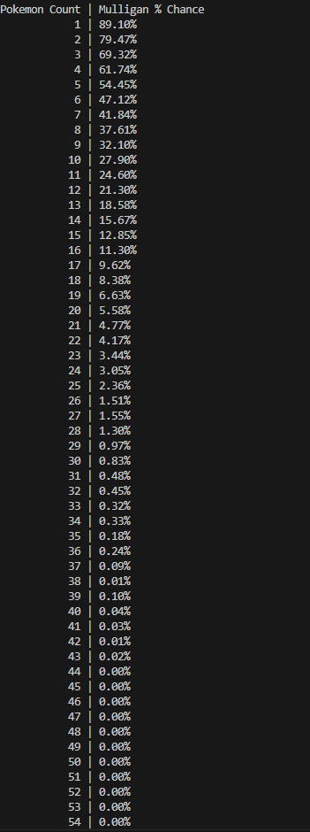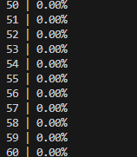

**Assignment 8 Formula Sheet**

**Purpose (Personal Opinion):**

The purpose of the formula sheet was to help us see all the equations we needed for exams. It also helped us get familiarized with how to write equations into a word document. It is a very handy tool.

**Screenshot Of Code: In Github**

**Assignment 9 Pokemon TCG Project**

**Purpose (Personal Opinion):**

**The purpose of this project was specifically said to us in class. It goes on our resume and shows we can code in todays “times”. Professor you specifically told us this project was for us and we can do as good or as little as we wanted. This was meant for us to learn and code something that is being used tremendously right now: PokemonTCG.**

**Use Of Inheritance:**

**I used inheritance with Pokemon Base Class all of my Pokemon card classes inherit from a common base class which is named Pokemon. This base class holds important information about the Pokemon which is name, hp, type, retreat, cost, and attacks.**

**The screenshot provides evidence of usage.**



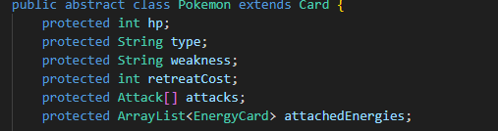

-

**Screenshot Of Code when there is a declared winner:**

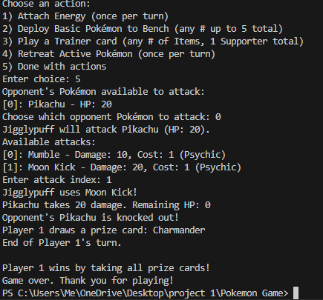

# **Shady’s Pokemon TCG Game Manual**

**Welcome to Shady’s Pokemon Trading Card Game Simulation! This manual explains how to play the game, the rules in effect, and what each phase of the game entails.**

## **1. Game Overview**

**In this simulation, each player builds a 60-card deck consisting of:**

* **15 Pokemon cards: These represent your battling Pokemon. Each Pokemon has specific stats (HP, type, weakness, retreat cost) and attacks.**
* **20 Energy cards: These provide the power needed for your Pokémon to use attacks. Energy cards must match your Pokemon’s type exactly (unless the Pokemon is “Colorless”).**
* **25 Trainer cards: These include Item cards (which can be played as many times as you wish) and Supporter cards (only one may be played per turn).**

**Win Conditions:**

* **A player wins when they collect all 6 prize cards (see below) by knocking out opposing Pokemon.**
* **Alternatively, if an opponent loses all Pokemon in play (active and bench) or cannot draw a card at the start of their turn (deck is empty), you win.**

## **2. Setup**

1. **Deck Preparation:  
    Each player's deck is automatically built and shuffled.**
   * **The deck contains the cards as described above.**
2. **Starting Hand:  
    Each player draws 7 cards. If a player does not have at least one Basic Pokemon in their starting hand, they must reveal their hand, perform a mulligan (return all cards to the deck and draw a new hand), and the opponent may draw one extra card.**
3. **Prize Pile:  
    After drawing your starting hand, each player takes 6 cards from the top of their deck to form their prize pile. These are the cards you'll win by knocking out your opponent’s Pokemon.**
4. **Active and Bench Pokemon:**
   * **Both players choose one Basic Pokemon from their hand to place as their Active Pokemon.**
   * **Additional Basic Pokemon may be placed on the Bench (up to 5).**

## **3. Turn Structure**

**Each turn consists of several phases. The order of phases is as follows:**

### **A. Draw Phase**

* **Draw 1 card from your deck at the start of your turn.**
* **If your deck is empty, you lose the game.**

### **B. Action Phase**

**During this phase, you can perform any (or all) of the following actions in any order, subject to these limitations:**

* **Energy Attachment:**
  + **You may attach exactly one Energy card per turn.**
  + **The Energy card must match the type of the Pokémon you are attaching it to (unless the Pokemon is “Colorless”, which only accepts “Colorless” energy in our simulation).**
* **Pokemon Deployment:**
  + **You may deploy additional Basic Pokemon from your hand to your Bench (up to a maximum of 5).**
* **Trainer Cards:**
  + **You can play Item cards (any number) or one Supporter card (only one per turn).**
  + **Trainer card effects (like healing, drawing extra cards, or reviving Pokemon) occur immediately.**
* **Retreat:**
  + **You can retreat your Active Pokemon once per turn.**
  + **To retreat, you must discard a number of attached Energy cards equal to the Pokemon's retreat cost, then select a Bench Pokemon to become the new Active Pokemon.**

### **C. Attack Phase**

* **Target Selection:**
  + **You choose which of your opponent’s Pokemon (either the Active Pokemon or one on the Bench) you want to attack.**
* **Attack Selection:**
  + **You view the available attacks for your Active Pokemon (each attack shows its name, base damage, energy cost, and required energy type).**
  + **You then choose which attack to use.**
* **Damage Calculation:**
  + **Damage is applied to the target Pokemon. If the target Pokemon’s weakness matches your attacking Pokemon’s type, damage is doubled.**
* **Knock Out & Prize:**
  + **If a Pokemon’s HP falls to 0 or below, it is knocked out.**
  + **When you knock out an opponent’s Pokemon, you collect one prize card from your prize pile.**
  + **A win is declared when a player collects all 6 prize cards.**

### **D. End Turn**

* **After the Attack Phase, your turn ends and play passes to your opponent.**

## **4. Additional Rules & Game Flow**

* **First Turn Rule:  
   The player who goes first (decided by a coin flip) cannot attack on their first turn.**
* **Win Conditions Recap:**
  + **Prize Cards: Collect all 6 prize cards.**
  + **No Pokemon Left: If your opponent has no Pokemon in play (neither Active nor Bench), you win.**
  + **Deck Depletion: If an opponent cannot draw a card at the start of their turn (because their deck is empty), they lose.**
* **Game Modes:**
  + **Player vs. AI: Only Player 1 is controlled by you; Player 2 makes automatic, simplified decisions.**
  + **Player vs. Player: Both players are controlled manually.**
* **Input:  
   The game runs in the console and prompts you for numeric inputs. Follow the on-screen instructions to progress through your turn.**

## **5. Example Turn Walkthrough**

1. **Draw Phase:  
    You draw one card from your deck.**
2. **Action Phase:**
   * **The game asks if you want to attach an Energy card. You review your hand and select a valid Energy card to attach to one of your Pokemon (e.g., attaching a Fire Energy to Charmander).**
   * **Next, you have the option to deploy another Basic Pokemon from your hand to your Bench.**
   * **Then, you can choose to play Trainer cards from your hand (remember, only one Supporter per turn).**
   * **You may also choose to retreat your Active Pokemon by paying its retreat cost.**
3. **Attack Phase:**
   * **The game displays your opponent’s Pokemon (both Active and Bench) along with their remaining HP.**
   * **You select a target and then view your Active Pokemon’s available attacks.**
   * **After choosing an attack, damage is calculated and applied.**
   * **If the target Pokemon is knocked out, you collect a prize card from your prize pile.**
4. **End Turn:  
    Your turn ends and play passes to your opponent.**

**That is the end of Shady’s Pokemon TCG Manual. THANK YOU!**

**Extra Credit Section**

**I’m not very good with acknowledging extra credit vs what we were supposed to do but I took a lot of time to make sure all my comments were very detailed and professional. I also made the game very playable for the user and very easy for anyone to learn. I made a very professional manual that looks good and is easy to read. In general, I tried my best to make this project organized and very professional. I gave meaning to energy/trainer cards made sure the game was balanced and that energy cards were only able to attach properly to the correct Pokemon. I made it so trainer cards had an actual meaning without just being placeholder cards. I gave every card a purpose. In general, I am not the best coder but I put a lot of effort into this project. I had to do some research about Pokemon TCG because from the start of the project, I was confused but I asked you questions and got right on track after that. I didn’t do well on the exam so I'm hoping that this project can make up for it I really want to graduate this semester and I hope this project can show my efforts. Thank you for an amazing first half of the semester! I’m really looking forward to learning more from you.**